WORLD HIGHWAYS
READ THE TEXT BELOW
PART A
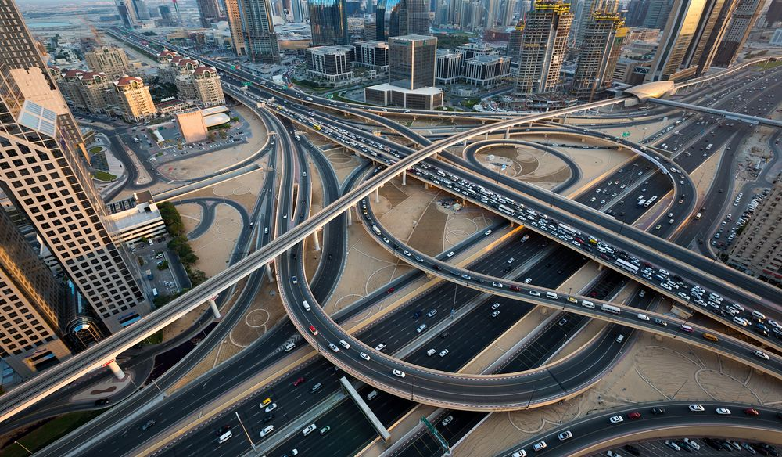
Since the dawn of civilization and the invention of the wheel, humanity has found the need to create paths and improve existing paths in order to facilitate easier and faster movement of people and goods. Modern societies have managed to improve the accessibility within and between regions through vast networks of roads and have improved the techniques used in road construction, such as the use of asphalt or concrete as a modern road construction material.

Accessing Road Quality
Road quality is determined by the extensiveness of a country's road network, as well and the condition of that network. The quality of the roads can vary from one country to another depending on these two parameters. Countries are ranked based on assigned scores which range from 1 to 7. A score of 1 indicates that the quality of roads is extremely poor, while a score of 7 means the quality of road infrastructure which is extremely good. The most recent Global Competitiveness Report on the quality of roads, as posted by the World Economic Forum, ranked the United Arab Emirates as having the best roads, with a total score of 6.4, while Mauritania was ranked last, with a score of 2 points. The quality of roads across the globe has been steadily improving, especially in developing nations in Africa and Asia, which are also reporting some of the highest rates of economic growth in the world. However, some developed nations have experienced a slight drop in the quality of infrastructure due to the recent financial crisis which has limited the amount of funds available for road maintenance.

Countries With the Best Roads

United Arab Emirates
The United Arab Emirates (UAE) ranks first globally in terms of road quality. This achievement has been attributed to sophisticated road infrastructural projects undertaken across the country, which are in line with the nation’s Vision 2021 program. Despite having the highest quality of roads in the world, the country has not scored as favorably in terms of road safety and traffic congestion. It is estimated that an average driver spends at least 11% of their driving time held up in traffic. The Dubai Police control room received an estimated 15,000 emergency calls and recorded over 1,100 road accidents resulting from poor driving and bad weather.

Singapore
Singapore is ranked second globally in road quality, with a score of 6.3. The island nation has an area of 279 square miles and an impressive 5,642 lane-miles of roads. The impressive score is as the result of the government’s decision to make significant investments in the nation’s road infrastructure.

Switzerland
Switzerland is ranked third in road quality. The European nation is renowned throughout the world for its excellent infrastructure and also ranks first in terms of electricity supply and second in the quality of its railroad infrastructure.

PART B Liwa Oasis

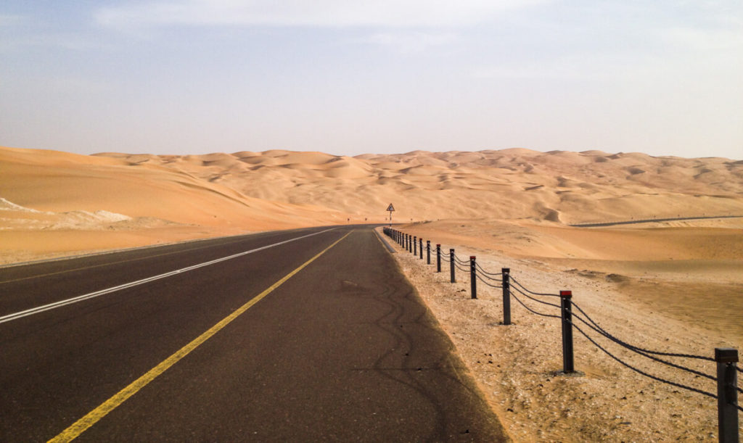
If you are into driving through desert areas, Liwa might make it to your list of best driving roads in UAE. Liwa is a vast desert area situated on the edge of the great Empty Quarter desert (Rub Al Khali). The long stretch of road running beside barren land might not be your ideal place for an adventure, but it has a charm of its own. You might not find twisting roads, tall mountains and dangerous cliffs in Liwa, but drifting up and down sand dunes can be fun. It would be an ideal place if you want to test your big wheels driving skills.
II Now answer the following questions based on the text.
- What are roads usually made of?
- What are the two parameters for determining road quality?
- What is road maintenance?
- Although the roads in UAE are in perfect condition, this country still experiences problems in traffic. What are some of them?
- What is traffic congestion?
- What is the highest score in road quality ranking?
- In which categories does Switzerland rank first, second and third nation in the world?
- Where is Liwa Oasis located and what makes driving interesting there?
- What kind of road infrastructure does Serbia have? Give some examples.
III Translate one passage from the text and create your own list of technical terms based on this text.

IV Fill in the text about Route 66 with the words given below
back, tourists, miles,traveled, drive, terminating
A Route 66 road trip is a driving adventure along what is probably the most famous road in the world. Historic Route 66 spans over 2,400 _________and crosses 8 states, starting in Chicago, Illinois and _____________ at the Pacific Coast in Santa Monica, California. Given its “66” designation in 1926, it became a well-_______ highway, bringing together people from all walks of life.
Today it is that classic road side culture and the appeal of the open road that continues to attract ____________. Route 66 has inspired songs, films, TV shows, books, and even a clothing brand. Even though Route 66 was officially decommissioned in 1985, people from around the world come to _________this mythic highway, stay in vintage motels, gawk at odd roadside attractions, and eat American road food. For some travelers, it is a trip_________ in time to revisit a road they once traveled on a family holiday, whereas for others a Route 66 road trip is the ultimate symbol of Americana.

